**CONICS**

***Definition:***   
A conic section is the intersection of a plane and a cone. By changing the angle and location of intersection, we can produce a circle, ellipse, parabola or hyperbola; or in the special case when the plane touches the vertex: a point, line or 2 intersecting lines.

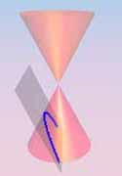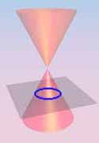 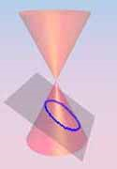 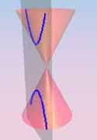

CIRCLE ELLIPSE PARABOLA HYPERBOLA

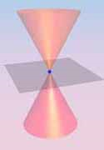 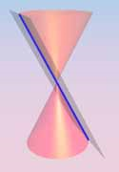 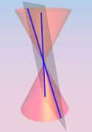

POINT LINE PAIR of STRAIGHT LINES

**General Equation of Conic $: {ax}^{2} + 2hxy +{by}^{2}+ 2gx+2fy+c=0$**

**Detail Classification of Conics**

|  |  |  |  |  |
| --- | --- | --- | --- | --- |
| **Case** | **Condition of Invariants** | **Types of Locus** | **Required form of equation** | **Reduces form of equation** |
| **Proper Conic: $$∆ ≠ 0$$** | $C>0, I and ∆ opposite in sign$; a=b, h=0 | **Circle** | $x^{2}$**+ $y^{2}$ + $2gx$ + $2fy$ + $c=0$** |  |
| $$C>0, I and ∆ opposite in sign$$ | **Ellipse** | $\frac{ x^{2}}{a^{2}}$**+ $\frac{y^{2}}{b^{2}}$ = 1** | $a^{,}x^{2}$**+ $b^{'}y^{2}$ + $\frac{∆}{C}$ = 0** |
| $$C<0$$ | **Hyperbola** | $\frac{x^{2}}{a^{2}}$ $\frac{y^{2}}{b^{2}}$**= 1** | $a^{,}x^{2}$**+ $b^{'}y^{2}$ + $\frac{∆}{C}$ = 0** |
| $$C = 0$$ | **Parabola** | $y^{2}$ $= 4ax$ | $$Y^{2}= 4AX$$ |
| $$C>0, I and ∆ same sign$$ | **No real locus** |  |  |
| **Degenerate Conic: $∆ = 0$** |  | **A pair of straight lines** | ${ax}^{2}$**+ ${ 2hxy+by}^{2}$ + $2gx$ + $2fy$ + $c=0$** |  |

Determinant **= $\left|\begin{matrix}a & h & g \\ h & b & f \\ g & f & c\end{matrix}\right|$ = $abc + 2fgh - af^{2}- bg^{2} - ch^{2}$**



$C = ab - h^{2}$

$I = a + b$

**, *C,*** and ***I*** are invariants under transformation.



**Invariant:** a relationship that is not changed by a designed mathematical operation such as transformation of coordinates (unchanged/constant/not varying).

**Locus:** the set of all points, lines, or surfaces that satisfy a given requirement.

# Conic Section

**Practice Sheet – Mat 110**

**Problems :**

1. Reduce the equation to its standard form:

i)

ii)

iii)

iv) 

v) 

vi) 

2. Find the center of the conic 